Article from Hartlebury Parish Magazine, November 2020

Hartlebury Common Local Group
In the countryside, we are nearly between the autumn ‘Season of mists and mellow fruitfulness’ of John Keats and the ‘… springtime, the only pretty ring time, when birds do sing, hey ding a-ding, a-ding …’ of William Shakespeare. Poets rarely compose such beautiful pictures of the winter season – unless, perhaps, when snow and frosts are involved!
I decided when I retired from work that I could get through the dark and cold (and sometimes depressing) winter days by being as active as I could! Health problems stopped the source of inspiration that I got from older friends with whom I had started playing badminton, and even tennis, throughout each winter. Yes, it is possible to have a variety of friendships and activities indoors that can keep most people happy during the short, dark days of the year; but, I’ve always realised that I was an ‘outdoor’ person - despite working in an office for 30-odd years. So, a growing interest in the natural world has brought great benefits to me.
But can you really enjoy the countryside in winter? Well a walk on a sunny, even if cold, day on Hartlebury Common can be most uplifting: the colours of the landscape can be amazing, the fresh air feels good and you pass other folk, often with their dogs, in a cheery mood! Winter is the time, too, when the views from the Common are at their best and sometimes clearest. Distant well-known prominences like Clent, Malvern, and Clee might be seen as well as the more local Trimpley, Stagborough and Abberley Hills: so from our relatively lowly common there is a panorama to match many a high hillside!
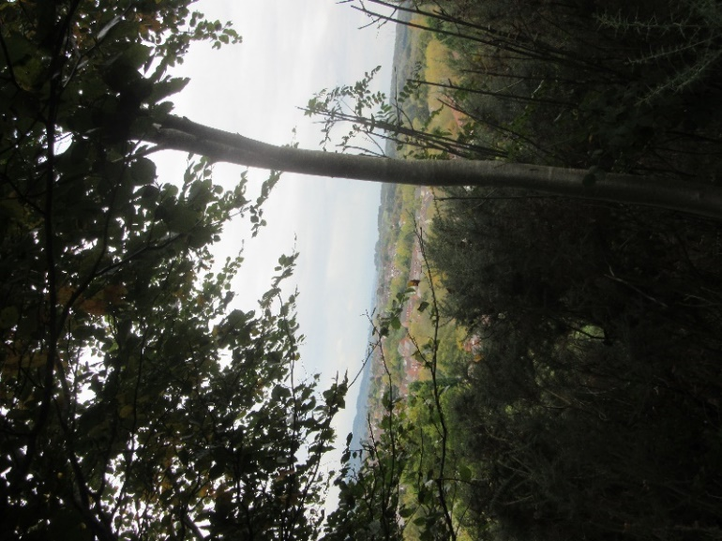
View over Stourport from Hartlebury Common – looking towards the (not visible) Clee Hills.
Winter wildlife watching or studying is possible too. It may not be the same as seeing fully-clothed trees or plants in full flower, but bare tree trunks and branches have a beauty of their own and many birds can be seen more easily at these times. Look out as well for passing birds – flying overhead, perhaps with no intention of staying. A growing interest in plant-life has shown me that mosses and lichen are often easier to spot and appreciate as they become a major part of the winter flora. Fascinating, too, is a ground-breaking ‘new’ book that I have discovered which allows the identification of plants without needing to see their flowering parts – allowing all year round botany! Anyway, I am looking forward to many enjoyable local countryside visits before the spring – dressed warmly and keeping dry and safe, of course.
Great news! Inspiration has returned to the Common in the form of local litter picking volunteers. Group members joined with ‘The Pick-up Artists’ (please see their Facebook page) in tackling the litter accumulated this year. This work is so beneficial for the Common and our community and has, in the past, prompted the Council to put some further resources into clearing the problem further.
Our talks and AGM are ‘on hold’ at the moment, but more good news for this autumn is that regular conservation volunteering activities for our group have resumed. Normally on one Thursday and one Sunday a month and, hopefully, continuing through the winter. Members find this work most rewarding and enjoyable (and is always conducted as a safe, supervised event). If you would like to join in, or become a member of our group, please go to our website for information.
hartleburycommon.org

(On the website is further information on the wildlife, together with many great quality pictures taken by local photographers).
Michael Howard

