Article from Hartlebury Parish Magazine, October 2020

Hartlebury Common Local Group

Disappearance in The Triangle
In that unexplored area of oak woodland between the lanes to Lower Poollands Farm and Hillditch Pool, small groups of our volunteers have managed to eradicate large areas of, the very invasive, Himalayan Balsam plants. This will now allow the usual oak wood flora (and fauna) to return to a normal state. My memories of that area will always be of a dawn chorus walk 30 years ago listening to a rare turtle dove and watching a nut-hatch run down a large tree.

Ferns - bracken
It's the time of year on the Common when another overwhelming, though indigenous, species gets noticed. Bracken is one of the few plants that enhance landscapes as their above-ground structures completely die back following the first frosts. Their swathes of reddish-brown colours make them more noticeable than when they were alive! Flourishing colonies, however, have to be held in check by careful management. Rapid proliferation of these strongly competitive plants means very little else can survive where they take over an area. Each year, when their spores are not active (before August), conservation volunteers might well be employed in bracken control to help preserve the heathland.

There are other ferns than bracken
It may be the diminished wildlife in bracken that has contributed to my previous lack of interest in ferns. All that has changed! During the lockdown in spring and early summer, I was determined to take my interest in plants further. I bought books on flowering plants and grasses (they also bear ‘flowers’) and learned quite a bit in the garden – I always wanted to know the names of the weeds and fully grown (overgrown really) grass! I had planned to go on some training days at the Field Studies Centre in nearby Bishop’s Wood. However, one by one, the training sessions got cancelled – except for a day learning about ferns. It seemed like a good idea to learn something completely new – to me, any big ferns were ‘more-or-less bracken’. Anyway, the day, climbing up Ironbridge Gorge, was very enjoyable (though I could hardly walk at the end!) – we saw 16 different types of ferns and related species. Well, I thought, that was very interesting but it has not developed my knowledge of plant-life on Hartlebury Common. However, looking at the, now, old book on Hartlebury Common some of these other ferns were recorded there. Exploring near the dark area of the aforementioned ‘triangle’, there were some of these – not uncommon ferns, but I could now name them (‘Male-ferns’- yes, that’s their name), previously thought of as ‘bracken-like’! There are rarer ferns of course (please see the following photograph), but whether they are still to be found here is something else to look out for.
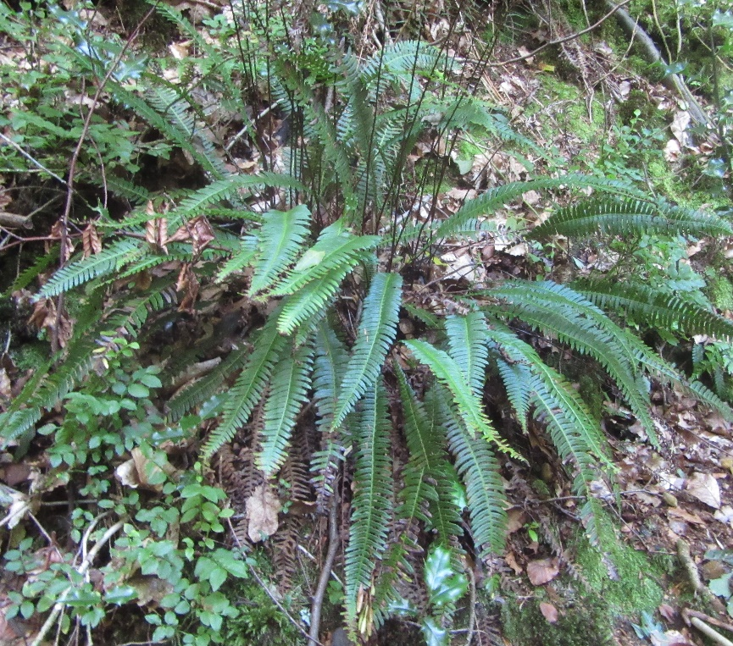
A rosette of ‘Hard-ferns’ (Ironbridge Gorge, 9 September 2020) – this fern has been recorded on Hartlebury Common

October on the Common
Fungi of many different types can be found, often by old tree stumps – especially after a spell of rain. Look out for the red-topped Fly Agaric near birch trees, but be aware that it is poisonous – SO PLEASE DON’T TOUCH!
Pretty blue Harebells may still be found and the Snap-dragon-like yellow Common Toadflax can be found late into autumn.
No summer migrant birds are left, of course, but some of our resident populations will be supplemented by others over-wintering from Scandinavia.
Otherwise, enjoy the autumnal colours in a picturesque setting.

Current restrictions mean that our meetings are cancelled for the foreseeable future. A possibility might be an internet talk if a speaker can be found. For all information and news, please see Hartlebury Common Local Group Facebook page or our internet site:
hartleburycommon.org
Michael Howard

