Article from Hartlebury Parish Magazine, July/August 2020

Hartlebury Common Local Group
Walking on Hartlebury Common is a relatively easy way to experience some different natural habitats: rare sandy heathland, Worcestershire's only area of bog, an ancient pond (Rush Pool), a mini-fenland at Hilditch and deciduous woodlands on most of its borders. Although seeing many of its inhabitants is not always easy, just knowing that we have such a diverse range of flora and fauna successfully living nearby could be something to be proud of; proud, too, of the beautiful landscapes we have there.
This pretty photograph of a quiet corner of the Common shows the Broom bushes in full flower (and some older Gorse flowers) this spring – just imagine the many small invertebrates and micro-organisms living within this scene. The photographer, Mike Lomax, might have been looking to record some of the butterfly numbers at the time.
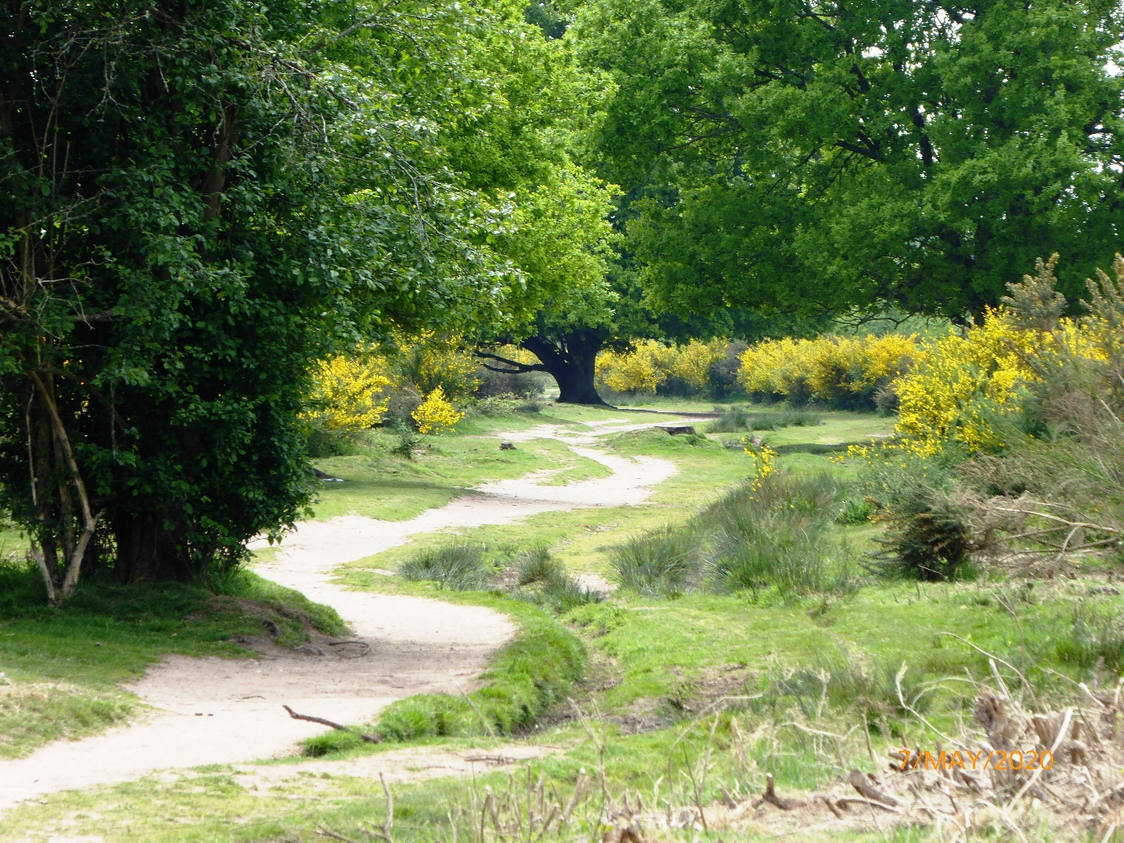
Broom bushes in full flower on Hartlebury Common (May 2020)

Myself, being quite a poor wildlife spotter, I have recently changed tactics and enjoyed many ‘Dawn Chorus’ walks on my own and so can concentrate on seeing all around me (on accompanied country walks, I’ve only ever remembered the conversation – all else was a blank!). The great cacophony of morning sound I was taking in came from all those little birds I would hardly ever see.
I'm getting to know different songs, though very slowly – have finally learned the Chiff-chaff (a migrant warbler) and was quite excited when I could clearly hear different males every 100 metres, or so. One time, and only following the sounds, I was trying to glimpse a woodpecker in a tree above and see a cuckoo in the next large tree at the same time. I didn't manage either, but the experience of hearing them was enough.
I must say that I felt good after each walk. My enthusiasm, during this long lockdown, must have shown, because one evening my grand-daughter said that she, too, would like to go on a walk in the morning! Remarkably, we were on the Common by 5.30 am. Armed with a camera, she got plenty of shots of little rabbits, a movie of a group of flying swans and even some dogs (with their owners, of course)! No cuckoo sounds that morning, though - the first time for a month! I was disappointed; but, just before leaving, overhead, with its long legs sticking right back, we saw a Grey heron. It seems that wildlife spotting is often the case of ‘expect the unexpected’ - as long as you are mindful of your natural surroundings.
In Hartlebury Common Local Group, we have been, fortunate to have had talks from speakers specialising in particular wildlife types. Some are also members of the group and have posted beautiful photographs and recorded sightings of species on our website and Facebook page.
Recently, we learned of various dragonflies and damselflies in the different wetland habitats; we’ve had visits from ravens and even a peregrine falcon. A recurrence here of Tower Mustard (a plant, in the UK, only found in Norfolk and a few other Kidderminster area locations), demonstrates the extra-special nature of this environment.
Walking gives me time to remember the work of the volunteers who help look after the Common: the litter pickers of all ages, the ladies who dug the wooden bollards in at the car park and the pathways and overgrowth kept clear. If only we had posters of these acts of kindness to welcome motorists entering the car parks! Discussion with the council has indicated that volunteering will not be possible on the Common for some time - due to simply getting their own staffing levels back to normal.
Our meetings and outdoor events have also, unfortunately, had to be cancelled – until at least the end of the summer. Please have a look at Hartlebury Common Local group Facebook page and our website hartleburycommon.org to find out much more about Hartlebury Common and the group’s activities and to join us.
We wish you all well during these changed times.
Michael Howard

