Article from Hartlebury Parish Magazine, June 2020

Hartlebury Common Local Group
Waiting all winter (and all autumn and most of spring) to see the return of the Swifts demonstrates the type of patience that can be learned from nature watching. Seeing just one in early May came as a relief - but I have not spotted one since! Their low numbers reminds me of the, also, long-awaited talk we were expecting by a speaker from a Shropshire Swift conservation group (Swifts have declined in numbers by more than half in the last 25 years). Hopefully the talk will be re-arranged when public meetings are again allowed. We must thank, meeting secretary, Jason Kernohan for arranging (and having to re-arrange) such an interesting programme of events.
Jason is also a keen naturalist and keeps our internet site www.hartleburycommon.org full of his interesting wildlife sightings on Hartlebury Common. Here he shares his photographs and experiences.

Spring on Hartlebury Common (Jason Kernohan)
With the UK being in lockdown since March, Hartlebury Common has been a lifeline as a place to exercise, walk and help with our wellbeing. For myself, being able to visit the Common has allowed me to continue observing and recording this wonderful habitat’s wildlife - something that I have been doing for a number of years.
Early Spring saw the beginning of a number of the Common’s migrant breeding birds return - with Chiffchaffs arriving first, in mid-March, from their wintering grounds in sub-Saharan Africa. Over the next few weeks, they were joined by Blackcaps, Whitethroats and Willow Warblers. Hartlebury Common is an important site for breeding warblers in Worcestershire and holds particularly high numbers of these species.
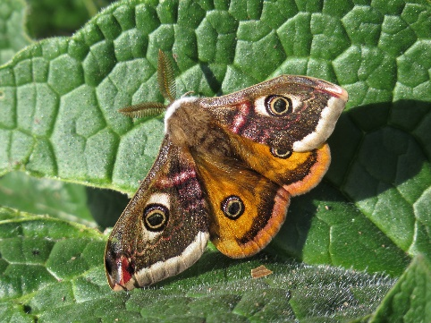
Emperor moth on Hartlebury Common (April 2020)
April (and early May) saw one of the Common’s most colourful residents active, the Emperor Moth. This large moth is a day-flying species and a specialist species of lowland heath sites. On warm Spring afternoons, the males can be seen patrolling over the Heather and the Bracken looking for females. April also saw the emergence of another of the site’s speciality species, the Green Hairstreak butterfly. It’s caterpillars like to feed on Broom, a shrub that it is plentiful on Hartlebury Common.
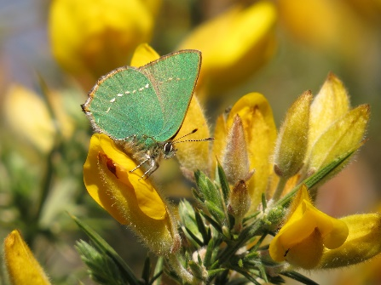
Green Hairstreak butterfly on Hartlebury Common
Late April also saw the return of a Cuckoo to the Common and from May there were two singing males present there. Hopefully, one of these will find a female, which generally return from Africa a few weeks later than the males. Unlike the male, which has the familiar ‘Cuckoo’ call, the female has a strange bubbling call. After mating a female will lay a single egg in another bird’s nest (usually a Dunnock, Meadow Pipit or Reed Warbler). The adult Cuckoos will soon leave and start heading back home on their long journey south; whilst the species whose nest it has laid its egg in will do all the hard work and mistakenly raise it as one of its own young. As the baby Cuckoo develops, it will throw its adopted siblings out of the nest and so receive all the food from its foster parents. When fully developed, the juvenile Cuckoos will fledge the nest during the summer months and this can lead to another few weeks of regular cuckoo calls. Fingers crossed, this will be the case on Hartlebury Common this year.
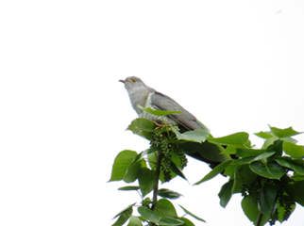
Cuckoo on Hartlebury Common (April 2020)

Up to the end of June, our indoor meetings and events on the Common are cancelled or postponed. We continue to hope that the events originally planned on Hartlebury Common later in the summer might go ahead. However, they would, first, need a revision of the government’s current restrictions on social distancing. For news on this and much more please look at our website at www.hartleburycommon.org.

Michael Howard

