Article from Hartlebury Parish Magazine, December 2020/ January 2021

Hartlebury Common Local Group
When I joined the group, about 9 years ago, I felt so inspired by the natural world that I started to study environmental science and biology – during my older years! Most of our members have a general to keen interest in the countryside and Hartlebury Common in particular. Our group is fortunate, as well, to have members with great wildlife knowledge, especially in certain areas (butterflies, moths, birds, dragonflies, etc.). Never hoping to catch up with any of these, I have thought that I would like to develop in one area, too.
Somehow, this year has confirmed that I will be learning more about plants. Being less knowledgeable than most gardeners (especially as to the names of weeds), never liking the glossaries of so many plant terms and with a somewhat struggling memory, I have now made a start. Yes, it really is surprising what you can learn whilst being locked down with a garden full of weeds – I learned their names whilst digging them up! I now intend to learn more about the plants on the Common and the many habitats that they support there – what a great place to start! Hopefully, in future, I’ll be able to record the ups and downs of its plant species and be able to explain more of the plant-life on our diverse nature reserve.
This month, our Webmaster, Jason, and Chairman, Mike, have kindly written articles on areas of their expertise. Excellent images of many of the species mentioned by them can be found on our website (address at the end).

The Winter Birds of Hartlebury Common (by Jason Kernohan)
When the country has to face restrictions designed to control the spread of Coronavirus, Hartlebury Common becomes a lifeline to our local communities giving us a place where we can walk, exercise and improve our mental well-being. If, like myself, you are interested in local wildlife, it also provides a place to catch up with and observe some of our local species. Even in the winter months, there is still much to see on the Common and hopefully I will highlight some of the birdlife that you may see when visiting.
By mid-autumn, Hartlebury Common’s breeding warblers will have left to migrate south to warmer climes. Also, a number of the site’s breeding ‘arable’ birds such as Linnets and Yellowhammers will have also departed. These two species will form flocks, roaming local fields to feed amongst the stubble or on the seed heads of left-over crops and perennial weeds. But birds are not just leaving us at this time of year, there are many arrivals: with ‘winter thrushes’, such as Redwings (see picture) and Fieldfares, returning from Scandinavia to feed up on our autumn/winter berries. A good place to look for these species are on Holly and Ivy berries in Hartlebury Common’s more wooded areas; but they will also feed on Rowan and Hawthorn trees that are dotted around too. With the arriving winter thrushes (Redwings and Fieldfares), also, comes a large influx of our more recognisable bird species: such as Robins, Blackbirds, Song Thrushes and Mistle Thrushes. These Scandinavian arrivals really do bolster our resident bird numbers and during the winter you, literally, can’t walk 10 metres without seeing a Robin perched up on a Gorse bush.
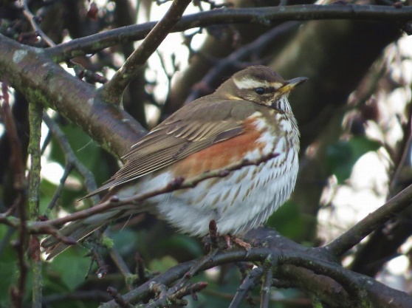
Redwing (Image: J Kernohan)
The colder winter temperatures cause the local Tit populations to form flocks to look for food together. These flocks also add an extra factor of safety, as there are more birds looking out for predators as they flit through the now leafless canopy. It’s always worth a look at these mixed flocks as amongst the regulars such as Blue Tits, Great Tits, Coal Tits and Long-tailed Tits you may spot something more unusual. These flocks can often be joined by Goldcrests, Nuthatches & Treecreepers and, if you are very lucky, you may even see a wintering Blackcap tagging along with them.
The Bog at Hartlebury Common can be a very interesting place during the winter months, especially as water levels rise and wet marsh channels form. Small numbers of Common Snipe (see picture) can be found here most winters feeding on invertebrates in the wet marshy ground. They have an incredibly long bill which is ideally suited for feeding in such habitats and are incredibly well camouflaged with their straw-coloured, streaky plumage allowing them to blend in perfectly with their surroundings.
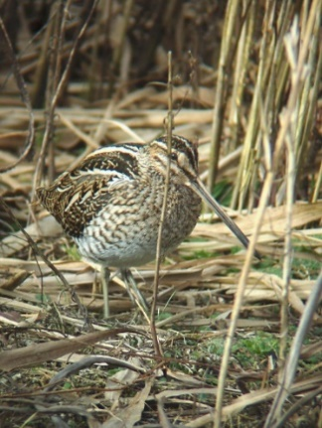
Common Snipe (Image: J Kernohan)
Some of the Common’s resident birds are present all year round and are often easier to see during the winter months. Kestrels can still be seen hovering over the open heath and the beautifully coloured Jays are much more conspicuous this time of year as they hop around, near the oak trees, gathering fallen acorns.
Hopefully, you too may see some of the wonderful species of birds that Hartlebury Common plays host to during your visits this winter.

Monitoring Butterflies on Hartlebury Common (by Mike Lomax)
In our July magazine, Michael Howard mentioned that I was often out on the Common ‘counting butterflies’. To explain this further, what I have been doing throughout the summer, and for the last 6 years, is walking a ‘Butterfly Transect’. Butterfly transects are a way of monitoring the number and variety of butterflies present at a site by walking the same route every week from the beginning of April to the end of September. They are part of a national scheme, the United Kingdom Butterfly Monitoring Scheme (UKBMS), which organises about 3,000 transects, all walked by volunteers, across the whole UK.
Butterfly transects are important because butterflies have a rapid life cycle and are highly sensitive to changes in environmental conditions. For this reason, they are good indicators of the state of the environment. The data generated by transects is used by many scientists to study the effects of climate change and to monitor the impact of conservation work. It’s ‘citizen science’ at work.

2020 findings
So, what are this year’s transect results? 2020 wasn’t a good year for butterflies on Hartlebury Common. I do the transect with Peter Smith and we counted 2,474 butterflies compared with 2,529 last year; it was the second lowest total in the last 6 years and the long term trend is down. This is in line with national trends and probably part of the very worrying massive decline of insects internationally. Although it could be that the unusual weather this year, very wet winter and an unusually warm and dry spring and early summer, affected conditions on the Common in a way detrimental to butterflies. I haven’t yet seen any regional or national transect results so, at the moment, don’t know if our results are typical, or not.

Some well-known butterflies have increased
However, not all the news is bad. The combined observations of butterflies known as the ‘whites’ (Large, Small and Green-veined) were way up on last year from 363 to 832 and had their best year on record. Red Admiral, Small Tortoiseshell and Peacock were, also, all up on last year, which is very good news as these are the butterflies that have suffered the steepest decline over the last decade or so.

Special Heathland butterflies
Out of the 24 species of butterfly recorded on Hartlebury Common, three are recognised as Lowland Heath specialists: Green Hairstreak, Small Copper and Small Heath. Of these, the Small Copper did very well: 132 were recorded this year compared to 82 last year, and it was the highest total for the 6 years of doing the transect. The other two species did not do so well. 21 Green Hairstreaks were recorded this year, compared to 38 in 2019. That sounds bad, but it is the second highest total in the last 6 years, and the long term trend is up. However, only 72 Small Heath were recorded compared to 117 in 2019: the lowest count since 2015.

Our AGM cannot take place under the present circumstances, neither can our normal monthly meetings and talks. However, ‘Zoom’ talks over the internet are being arranged as follows:
Rosemary Winnall on ‘Gardening for Wildlife’ 1st February
Mike Southall on ‘Butterflies and Moths of Bolivia’ 1st March
Please see our Facebook page and website for further details or if you would like to join us as a member:
hartleburycommon.org
We wish everyone a Happy Christmas and a better New Year!
Michael Howard

